EXPERIMENT ASSESSMENT

ACADEMIC YEAR 2025-26

Course: Multidisciplinary Minor
Course code: MDC401
Year: SE SEM: IV

Experiment No. 4
AIM: Develop a dynamic webpage where content updates on button click using JavaScript DOM. Implement jQuery effects: hide/show elements, toggle visibility, and animate elements.
Name: Ashish Ramesh Patel
Roll Number: 55
Date of Performance:
Date of Submission:
Evaluation
Performance Indicator | Max. Marks | Marks Obtained
Performance | 5
Understanding | 5
Journal work and timely submission. | 10
Total | 20

Performance Indicator | Exceed Expectations (EE) | Meet Expectations (ME) | Below Expectations (BE)
Performance | 5 | 3 | 2
Understanding | 5 | 3 | 2
Journal work and timely submission. | 10 | 8 | 4

Checked by
Name of Faculty : Dr. Yogesh Pingle

Aim: Develop a dynamic webpage where content updates on button click using JavaScript DOM. Implement jQuery effects: hide/show elements, toggle visibility, and animate elements.

Theory:
- JavaScript and the DOM (Document Object Model):
  - The DOM is a hierarchical representation of the elements on a webpage. It allows programming languages like JavaScript to interact with the structure, style, and content of the page.
  - Using DOM methods, we can:
    - Access elements (getElementById, getElementsByClassName, querySelector)
    - Change content (innerHTML, textContent)
    - Modify attributes (setAttribute, removeAttribute)
    - Change styles dynamically (style.property)
  - Example: Changing the text of a paragraph when a button is clicked enhances user interactivity.
- Dynamic Webpage Content:
  - A dynamic webpage changes content without reloading the page.
  - Dynamic updates improve user experience by allowing real-time feedback and interactivity.
  - In this lab, content updates are achieved using document.getElementById().innerHTML to manipulate text dynamically.
- Introduction to jQuery:
  - jQuery is a lightweight, fast JavaScript library that simplifies:
    - HTML document traversal and manipulation
    - Event handling
    - Animations and effects
  - jQuery is cross-browser compatible, meaning the same code works in different browsers without modification.
Syntax Example:
$(selector).action();
    - $() is the jQuery function
    - selector identifies the HTML element
    - action() is the method applied (like hide(), show(), animate())
- jQuery Effects and Animations:
  - Hide/Show: Instantly hide or show elements.
  - Toggle: Switch visibility state of an element (hide → show, show → hide).
  - Animate: Allows smooth transitions of CSS properties (like height, width, opacity, margins).
  - Benefits of jQuery Effects:
    - Improves visual interactivity
    - Reduces manual CSS manipulation
    - Provides smoother user experience
- Integration of JS DOM and jQuery:
  - Using pure JavaScript allows control over element content and structure.
  - Using jQuery complements JS by handling animations and effects more efficiently.
  - Combining both allows for dynamic and interactive web pages where content changes and user interactions are smooth and visually appealing.
- Applications:
  - Dynamic webpages are used in:
    - Online forms that validate inputs instantly
    - Content sliders and carousels
    - Real-time notifications
    - Interactive dashboards

Procedure
- Include jQuery CDN:
- <script src="https://code.jquery.com/jquery-3.7.0.min.js"></script>
- Create HTML element:
- <div id="box">Hello</div>
<button id="btn">Toggle</button>
- Apply jQuery:
- <script>
$('#btn').click(function(){
$('#box').toggle(500);
});
</script>

Code:
<!DOCTYPE html>
<html lang="en">
<head>
<meta charset="UTF-8">
<meta name="viewport" content="width=device-width, initial-scale=1.0">
<title>Experiment 4: DOM & jQuery</title>
<script src="https://ajax.googleapis.com/ajax/libs/jquery/3.7.1/jquery.min.js"></script>

<style>
body { font-family: Arial, sans-serif; padding: 20px; line-height: 1.6; }
.box { width: 150px; height: 150px; background-color: #3498db; margin: 20px 0; border-radius: 8px; }
.controls { margin-bottom: 20px; }
button { padding: 10px 15px; cursor: pointer; margin-right: 5px; }
#dynamicText { font-weight: bold; color: #2c3e50; }
</style>
</head>
<body>

<h2>Experiment No. 4: Dynamic Webpage with jQuery</h2>

<div class="controls">
<p id="dynamicText">Original Content: Waiting for interaction...</p>
<button onclick="updateContent()">Update Content (Pure JS DOM)</button>
</div>

<hr>

<div class="controls">
<h3>jQuery Effects & Animation</h3>
<button id="hideBtn">Hide</button>
<button id="showBtn">Show</button>
<button id="toggleBtn">Toggle Visibility</button>
<button id="animateBtn">Animate Element</button>
</div>

<div id="targetBox" class="box"></div>

<script>
// 1. Pure JavaScript DOM Manipulation
function updateContent() {
const textElement = document.getElementById('dynamicText');
textElement.innerHTML = "Success! Content updated via JavaScript DOM.";
textElement.style.color = "#e74c3c";
}

// 2. jQuery Effects
$(document).ready(function(){

// Hide & Show
$("#hideBtn").click(function(){
$("#targetBox").hide(500);
});

$("#showBtn").click(function(){
$("#targetBox").show(500);
});

// Toggle Visibility
$("#toggleBtn").click(function(){
$("#targetBox").toggle(300);
});

// Animate
$("#animateBtn").click(function(){
$("#targetBox").animate({
width: '300px',
opacity: '0.5',
marginLeft: '50px'
}, 800).animate({
width: '150px',
opacity: '1',
marginLeft: '0px'
}, 800);
});
});
</script>
</body>
</html>

Output:

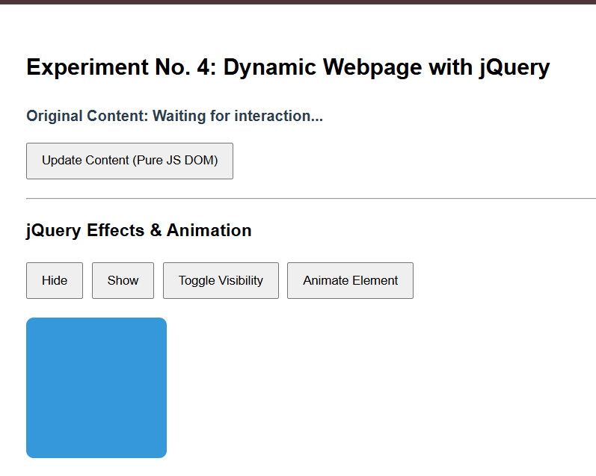
Update Button is clicked: Message is printed saying “Success! Content updated via JavaScript DOM.”
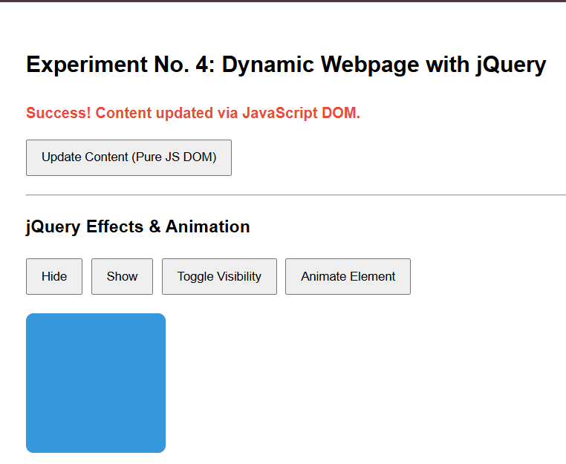

Hide Button is clicked: the blue box is hidden
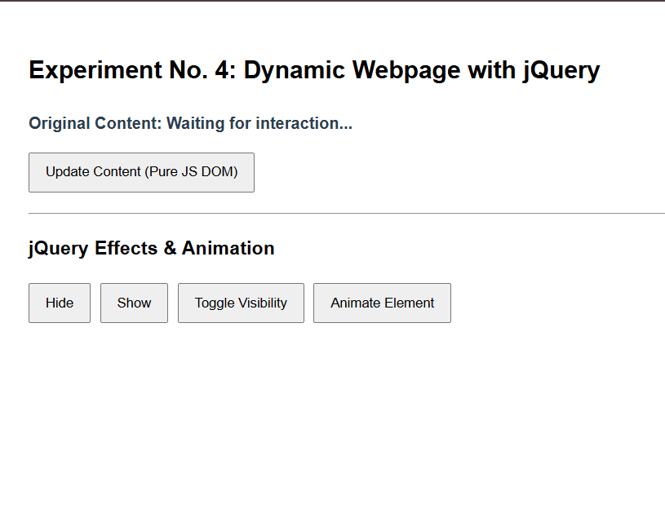

Show Button is clicked: the blue box reappears


“Animate Element “ Button is clicked: the blue box’s size changes and is again restored after one second.

Before :


After:
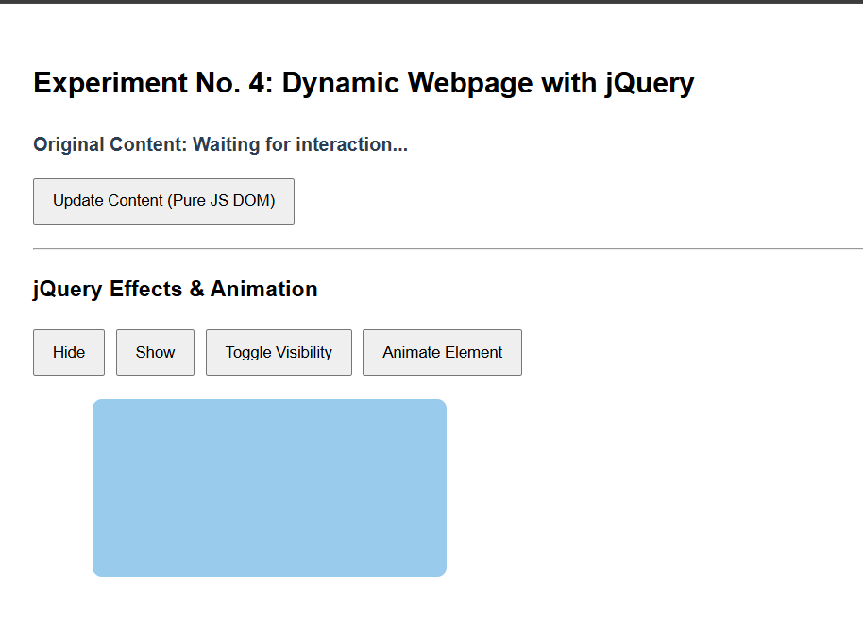

Conclusion
JavaScript DOM allows dynamic updating of webpage content in real-time. jQuery simplifies element manipulation, effects, and animations. Combining both creates interactive and visually appealing webpages, enhancing user experience. This lab demonstrated practical implementation of content updates, visibility toggling, and animations.
Question:
- What is the difference between .hide() and .toggle() in jQuery?
Ans:
Aspect | .hide() | .toggle()
Definition | Hides the selected element(s) | Switches between showing and hiding element(s)
Functionality | Only makes element invisible | Acts like a switch: if visible → hide, if hidden → show
Use Case | When you want to permanently hide an element | When you want to alternate visibility on user action

- How can you stop an ongoing animation in jQuery before it completes?
Ans:
Definition: jQuery provides .stop() method to halt animations before completion.
Key Points:
- Syntax: $("#element").stop();
- Stops current animation immediately.
- Prevents queueing of further animations.
- Useful for interactive UIs where user actions interrupt animations.

- How can you use jQuery to fade in and fade out an element?
Ans:
Definition: jQuery provides methods to gradually change element visibility with animation.
Key Points:
- Fade In: $("#element").fadeIn(); → gradually makes element visible.
- Fade Out: $("#element").fadeOut(); → gradually hides element.
- Can specify speed: "slow", "fast", or milliseconds.
- Enhances user experience with smooth transitions.

